Fleetwood Town Council
Onward to a Better Future
Allotment Committee Meeting
Tuesday 11 ^{th} November 2025 at 6pm
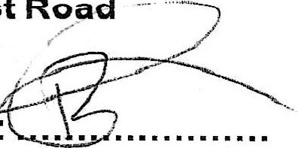
Warrenhurst Hall, Warrenhurst Road
Robbie Raynor (Chairman) — Signature:
Minutes
020 | Opening of the meeting — Chairman  The Chairman welcomed all to the meeting
021 | To receive and record apologies — Chairman  Present: Chair, Councillor Raynor, Councillor Swatton; Assistant Clerk  Plot Holders: CO, DO, SJ, CV, WB, ps, PG, WT, LO, LF, GF, KT. RRB  Not present (and no response) from Cllr Alice Jones and Cllr Jimilai Vukuruvakadua.
022 | To review and approve the minutes from the previous meeting, held, September 2025 — Chairman  The minutes of the meeting were accepted by those who had been in attendance.  Approved by?iAe—  Seconded by S
023 | To record Disclosable Pecuniary Interests from members (including their spouses, civil partners or partners) in any item to be discussed. Committee members MUST NOT make representations or vote on the matter therein — Chairman  None
024 | To record Other (Personal or Prejudicial) interests from members in any item to be discussed. Committee members should state if they need to bar themselves from discussion and voting on any related matters — Chairman
Fleetwood Town Council
Onward to a Better Future
 |  | None
025 |  | To discuss Plot 22 — making the plot smaller to create larger turning circle and to create possible starter plot - Chairman/ALL  It was agreed by all present that Plot 22 could be made into smaller plots; however the possibility of a new survey would be re-discussed once more members were on the Allotment Committee.  Separately, for those who wanted to be considered to become a member of the Committee, their details were passed onto the Assistant Clerk (AC). To be voted on at next FTC meeting-
026 |  | To discuss security by Carol Vance  CV — stated Lock Shop provide lock and keys to be sort directly from them.  Agreed to research possible alternatives for lock on Allotment gate — A  All plot holders should be reminded that keys should not be duplicated and handed out.
027 |  | Update on points for discussion at next meeting — Chairman / ALL.  To discuss update for allotment contracts and plan going forward. — agreed contracts need amending, all new documents to be re-issued to tenants and signed. Review of vacant plots Action AC.  Plot 5, rent issue —AC to chase.  PG — waiting list application —AC to chase.  To discuss update regarding quotes for Tree/hedge trimming. — It was raised that the trees on both Sides of the allotments required trimming — currently awaiting quotes. AC  Find out Allotment Treasury — needs chasing AC.  To discuss update regarding FiB with HS with CV — no update  needed. Closed.
028 |  | To set a date and time for the next meeting — Chair/ All. It was agreed that the next meeting would be 13/01/2026 6pm at Warrenhurst

